**Question 3: Explain the role of the Application Tier in a three-tier architecture and the typical firewall rules associated with it.**

**Answer-**

**Role of the Application Tier in a Three-Tier Architecture**

The Application Tier, also known as the business logic tier or middle tier, is a crucial component of a three-tier architecture, which typically includes the following layers:

1. **Presentation Tier** (Web Tier)
2. **Application Tier** (Business Logic Tier)
3. **Data Tier** (Database Tier)

**The primary role of the Application Tier is to process the business logic and data transformation tasks between the Presentation Tier and the Data Tier. Here’s a detailed explanation of its functions:**

**Functions of the Application Tier**

1. **Business Logic Processing**: This tier contains the business logic of the application, implementing the rules and operations that define how data can be created, stored, and modified.
2. **Data Processing**: It handles the data transactions and operations required by the application. This includes validating input data, processing user requests, and performing calculations.
3. **Communication**: It serves as an intermediary between the Presentation Tier and the Data Tier, managing the communication and data exchange between the two.
4. **Load Balancing**: In larger systems, the Application Tier is often distributed across multiple servers to handle a high volume of requests, ensuring that no single server becomes a bottleneck.
5. **Security Enforcement**: This tier enforces security policies, including authentication and authorization, ensuring that only valid users can access the system and perform allowed operations.

**Typical Firewall Rules Associated with the Application Tier**

**Firewall rules for the Application Tier are crucial for ensuring secure communication and proper segregation of the tiers in a three-tier architecture. Here are the typical firewall rules:**

**Inbound Rules**

1. Allow Traffic from Web Tier:
2. Source: Web Tier Subnet (e.g., 10.0.1.0/24)
3. Destination: Application Tier Subnet (e.g., 10.0.2.0/24)
4. Ports: Specific ports required by the application, such as HTTP (80), HTTPS (443), or custom application ports.
5. Protocol: TCP
6. Action: Allow
7. Allow Management Traffic
8. Source: Trusted IP addresses (e.g., admin workstations)
9. Destination: Application Tier Subnet
10. Ports: SSH (22) for Linux, RDP (3389) for Windows
11. Protocol: TCP
12. Action: Allow

**Outbound Rules**

1. Allow Traffic to Data Tier:
2. Destination: Data Tier Subnet (e.g., 10.0.3.0/24)
3. Ports: Database-specific ports, such as MySQL (3306), PostgreSQL (5432), SQL Server (1433)
4. Protocol: TCP
5. Action: Allow
6. Allow Traffic to Web Tier:
7. Destination: Web Tier Subnet
8. Ports: Specific ports needed for communication (e.g., HTTP/HTTPS)
9. Protocol: TCP
10. Action: Allow
11. Deny All Other Traffic:

**This ensures that the Application Tier cannot communicate with any other subnets or IP ranges that are not explicitly allowed.**

Action: Deny

**Example**

* **Inbound Rules for Application Tier (AppNSG)**

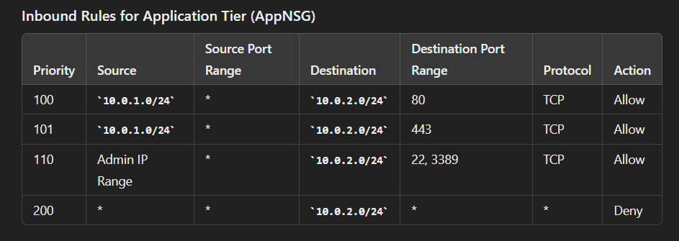

* **Outbound Rules for Application Tier (AppNSG)**

